# Instructions

## There are **2** questions in this assignment.

* Email/paper/other modes of submissions will not be accepted.
* Upload a word **version** of this document.

## Assignment submitted after due date will not be evaluated and a score of zero will be awarded.

* Plagiarism may lead to award of zero marks.

# Due Date: 12pm, 4th Sept. 2024 Submitting this Assignment

## You will submit (upload) this assignment in MS Teams. Name this document as GLA1_AJPODD2024_John_Doe.doc in case your name is John Doe, and this graded lab assignment is 1 of course whose acronym is AJP, and offered in ODD 2024. Paste your code after each question, paste the screenshot of output, save and upload the document.

**Grading Scheme:** This assignment has 5 marks.

# Question 1:

## Create a web page for internal links; when the user clicks on different links on the web page it should go to the appropriate locations/sections in the same page.

OUTPUT:

<!DOCTYPE html>

<html lang="en">

<head>

<meta charset="UTF-8">

<meta name="viewport" content="width=device-width, initial-scale=1.0">

<title>Toggle Sections Example</title>

<style> body {

font-family: Arial, sans-serif; line-height: 1.6;

margin: 0;

padding: 0;

}

nav {

background-color: #333; padding: 10px;

position: fixed; width: 100%;

top: 0;

z-index: 1000;

}

nav a {

color: white; margin: 0 15px;

text-decoration: none; font-size: 18px; cursor: pointer;

}

section { display: none;

padding: 60px 20px; margin-top: 50px;

}

h2 {

margin-top: 0;

}

.visible { display: block;

}

</style>

</head>

<body>

<!-- Navigation Bar with Links -->

<nav>

<a onclick="showSection('about')">About</a>

<a onclick="showSection('experience')">Experience</a>

<a onclick="showSection('contact')">Contact</a>

</nav>

<!-- About Section -->

<section id="about">

<h2>About Me</h2>

<p>

Welcome to my personal webpage! I'm a passionate professional with expertise in engineering management, product development, and more. My journey in the tech industry has been driven by a love for innovation and a commitment to delivering high-quality solutions.

</p>

</section>

<!-- Experience Section -->

<section id="experience">

<h2>Experience</h2>

<p>

I have over 10 years of experience in the tech industry, working across various roles and projects. My most recent position was as a Senior Engineering Manager at a leading e-commerce company, where I led a team of engineers to deliver scalable and efficient solutions.

</p>

</section>

<!-- Contact Section -->

<section id="contact">

<h2>Contact Me</h2>

<p>

If you'd like to get in touch, please feel free to reach out via email at [vartikashah27@gmail.com](mailto:vartikashah27@gmail.com) or connect with me on LinkedIn. I'm always open to discussing new opportunities, collaborations, or just having a chat about the industry.

</p>

</section>

<!-- JavaScript to Toggle Sections -->

<script>

function showSection(sectionId) {

// Hide all sections document.querySelectorAll('section').forEach(section => {

section.classList.remove('visible');

});

// Show the selected section document.getElementById(sectionId).classList.add('visible');

}

</script>

</body>

</html>



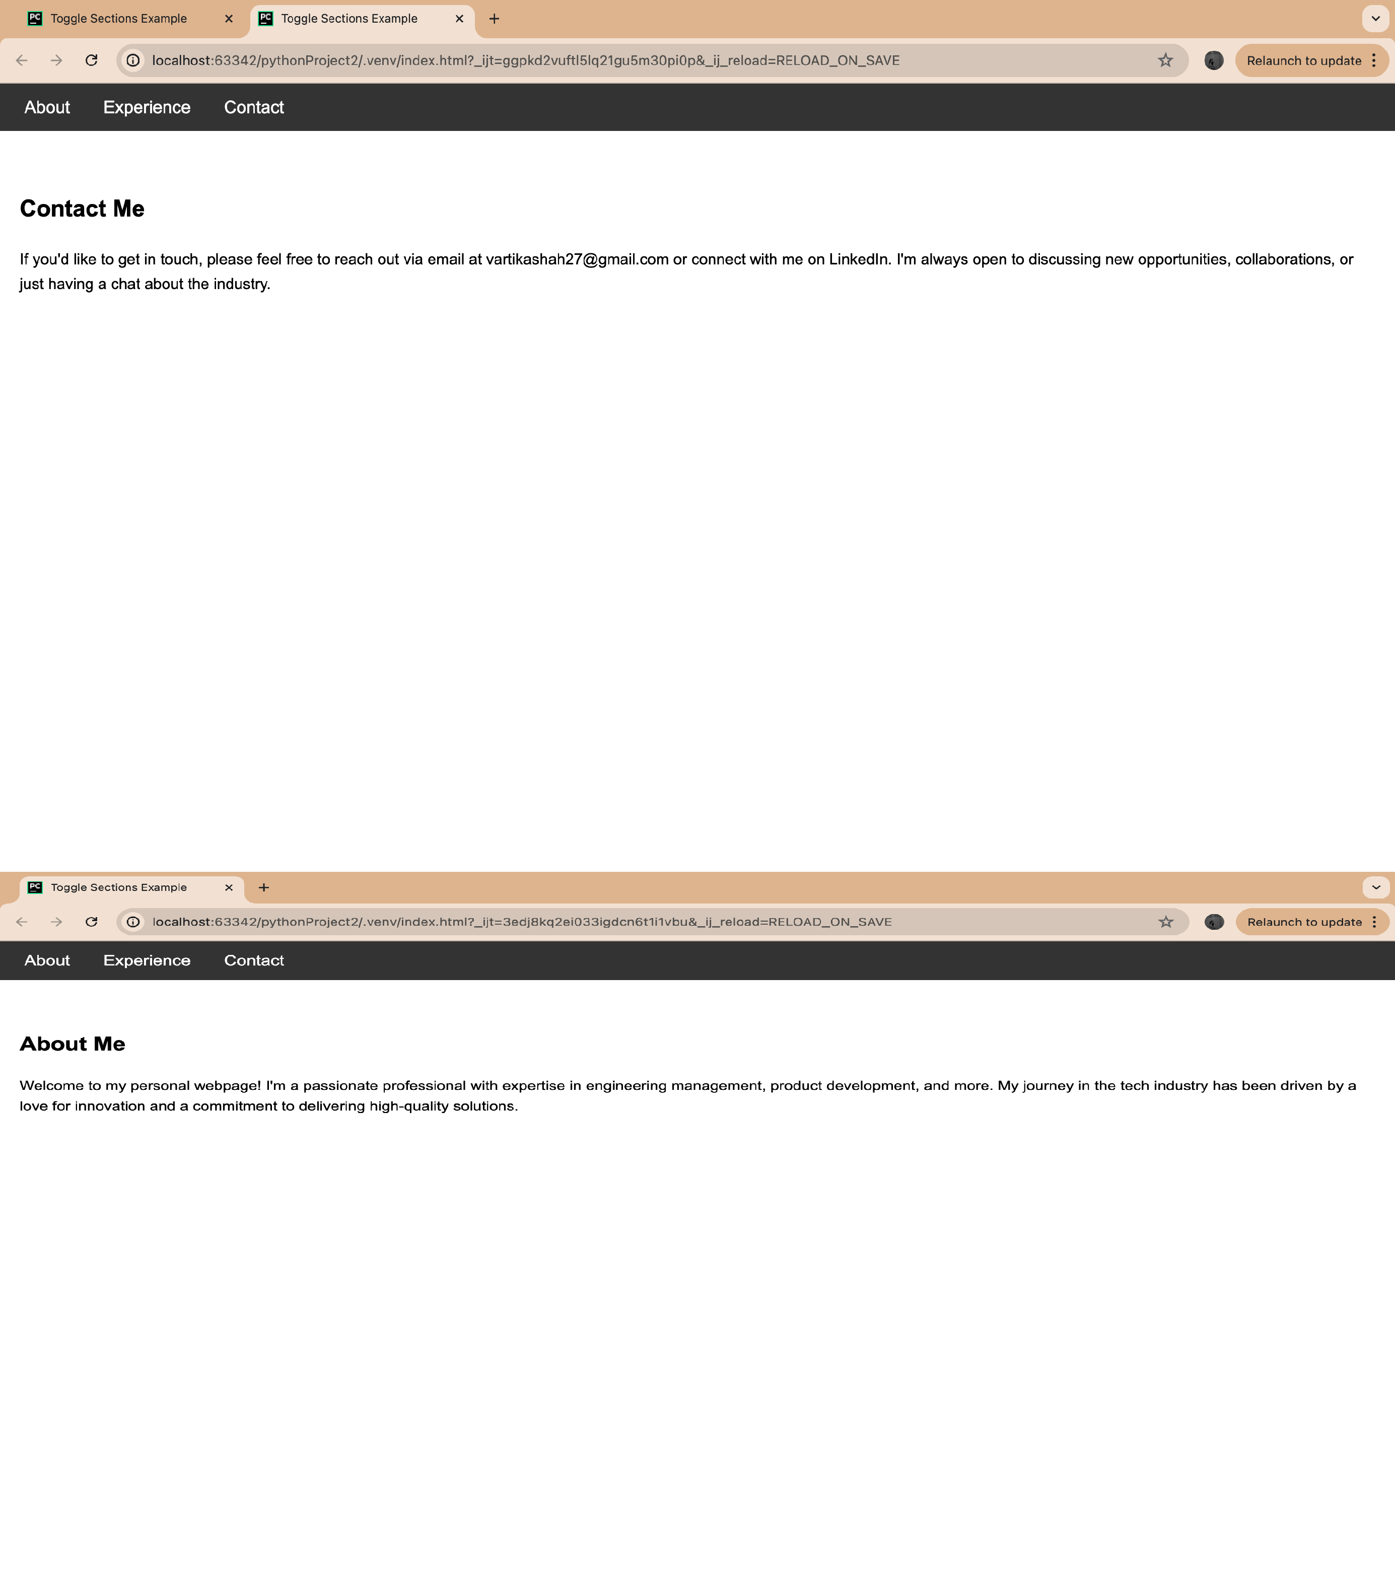

# Question 2:

## Create a web page, showing an ordered list of all semester courses enrolled.

<!DOCTYPE html>

<html lang="en">

<head>

<meta charset="UTF-8">

<meta name="viewport" content="width=device-width, initial-scale=1.0">

<title>Semester Courses</title>

<style> body {

font-family: Arial, sans-serif; line-height: 1.6;

background-color: #f9f9f9; margin: 0;

padding: 0; display: flex;

justify-content: center; align-items: center; height: 100vh;

}

.container {

background-color: white; padding: 20px 30px; border-radius: 10px;

box-shadow: 0 0 10px rgba(0, 0, 0, 0.1);

}

h1 {

text-align: center; color: #333;

}

ol {

padding-left: 20px;

}

li {

margin: 10px 0; font-size: 18px;

}

</style>

</head>

<body>

<div class="container">

<h1>Semester Courses</h1>

<ol>

<li>Introduction to Computer Science</li>

<li>Data Structures and Algorithms</li>

<li>Operating Systems</li>

<li>Database Management Systems</li>

<li>Software Engineering</li>

<li>Computer Networks</li>

<li>Artificial Intelligence</li>

</ol>

</div>

</body>

</html> Output:

